State Highpoint Data Visualization

Process Book

**By Jonathan Himes and Jesus Hurtado**

**Project Repository**

<https://github.com/HeyZeus02/DataVizProject2022>

# Background and Motivation

Many outdoor enthusiasts and climbing communities have a goal of visiting the highest point of elevation in each of the 50 states of the US. Some highpoints, such as the Black Mesa highpoint in Oklahoma, are easy hikes. Other highpoints, such as Mount Rainier in Washington, can be a multiday mountaineering expedition. Various clubs, groups, and message boards have been created to discuss and share experiences in this pursuit.

A limitation in communicating these experiences is access to a way to present the data. It has been observed, by at least one team member, that individuals with access and proficiency in ESRI’s GIS software are able to garner a lot of interest from both outdoor and non-outdoor enthusiasts. This software is expensive, however, and most users require significant schooling to learn to use the software.

The ability to effectively communicate your trip experience is rewarding in and of itself. The rise and popularity of social media platforms is testament to the fact that people like to share their accomplishments and interests. Being able to visualize visit experiences also generates interest in people who have never done anything like this before. This can lead to more enthusiasm for being outdoors. More enthusiasm in the outdoors can lead to more concern for the conservation of the environment and our outdoor spaces.

# Project Overview

The objective of this project is to develop a simple, easy to use website that provides users unskilled in data visualization or lacking access to visualization software the ability to generate custom visualizations that can be used to communicate their progress in visiting the highpoints in each state.

The users would input basic information such as which state highpoints they have visited and the date of their visit. The website would take this data and other data not provided by the user and generate a set of visualizations. The user can then download and share these high-quality visualizations summarizing their experiences.

The user will also be able to explore basic information about the US peaks on the landing page such as location in the United States and a bar chart comparing their elevations.

# Related Work

* [https://www.peakbagger.com/ListIndx.aspx?cid=0&unit=m#1](https://www.peakbagger.com/ListIndx.aspx?cid=0&unit=m%231) – This site provides data for various highpoints around the world in tabular format and has a map but does not go any further in visualizing the data.
* The AllTrails app creates basic stats about hikes but is not tailored to just highpoints. Graphical user interface, application

  Description automatically generated
* This is a page of a map journal done by a friend showing cumulative flights. We want to apply this to highpoints.Map

  Description automatically generated

# Questions

* What are the highest peaks in each US state?
* Where are they located at in relation to each other?
* What are their elevations?
* How do their elevations relate to each other?
* How many peaks has the user visited?
* What is the total elevation the user climbed in visiting the peaks?
* What percentage of peaks has the user climbed?
* What percentage of peaks has the user not climbed?
* What year did the user climb the most?
* Can the user share the data about his climbs with others easily?

These questions have not evolved much since the initial proposal. One interesting additional question we came up with is:

* What percentage of the highpoints are within 10 miles of the edge of the state.

In the future, we hope to be able to add features that answer weather questions.

# Data

At the current stage of the project, data will be coming from the following sources.

* Geographical Data (Latitude, Longitude, Elevation) <https://en.wikipedia.org/wiki/List_of_U.S._states_and_territories_by_elevation>

[https://www.peakbagger.com/ListIndx.aspx?cid=0&unit=m#1](https://www.peakbagger.com/ListIndx.aspx?cid=0&unit=m%231)

* State GeoJSON file

<https://www.kaggle.com/datasets/pompelmo/usa-states-geojson?resource=download>

* Weather data

NOAA API - <https://www.ncdc.noaa.gov/cdo-web/webservices/v2#gettingStarted>

* User input csv

This will include:

* + Highpoints visited
  + Dates of visits

# Exploratory Data Analysis

We came into the project with a clear understanding of what our raw data included so a lot of exploratory analysis was not required.

We did notice once we had mapped our data an interesting feature that a lot of the highpoints were right on the edge of the states that wasn’t apparent from looking at the tabular data.

# Design Evolution

We started the project with a clear idea that we wanted the website to be broken up into 3 pages separated by tabs.

While working on the project, we thought using mountains as tabs would increase the user experience. These mountains were created by the user and may be replaced by more professionally looking mountains.

Originally, there was going to be a feature to add in notes and user’s hiking experience but we found that this would muddle the overall goal of showing the basic hiking stats.

Color choices were in flux and may change throughout the life of this visualization.

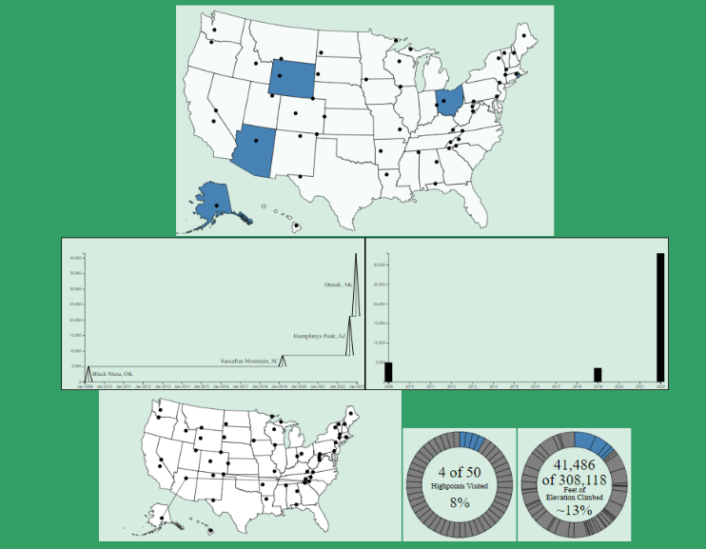

# Implementation

## Landing Page

The goal is to show overall statistics about US highpoints

### Overall Map

Shows the location of each highpoint. More functionality will be added when a hover tooltip displaying the peak, state, and elevation is added.

### Table

Shows a comparison of the elevations and the names of each state in an easy to lookup and sort manner. More functionality was added to highlight peak that is selected in the map.

### Final Overall Landing Page

Our landing page evolved to be in a grid based layout. The map and table are linked with highlighting. There is a welcome spot and an area to get more information about a state when clicked.

## Input Page

Allows user to input data. Formatting and user directions still to be added.

It changed from just providing basic downloading and input functions to include instructions.

### Input CSV

This is the format of the csv that user downloads, fills out and then uploads. It remained consistent throughout the project.

### Output Page

Below are a few iterations of the output page throughout the project.

### Completed States Map

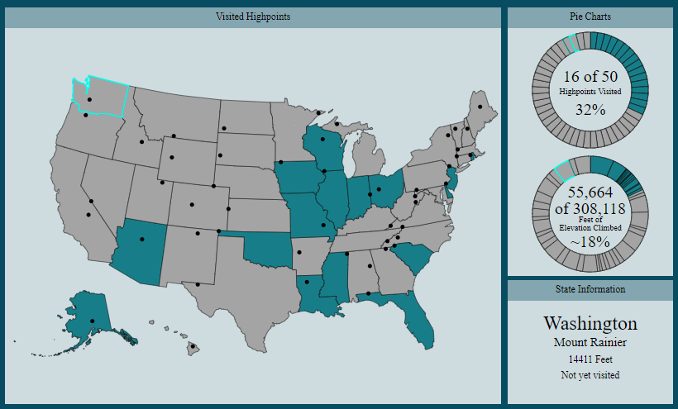

We realized that the completed states map corresponded nicely with the donut charts so we put them side by side. At first a tooltip gave information about each state when hovered but we found it clunky so we add an info box in the bottom right corner that gives you information about the state clicked on.

### Cumulative Time Series

When labels overlap, they are removed and become available by hovering.

A lot of thought and coding went into ensuring that the labels do not overlap. For example, in this extreme case, the smallest highpoints were all visited in the same year. To avoid label overlapping, any label that overlaps is hidden and becomes available when the specific highpoint is hovered over.

### Donut chart of mountains climbed and yet to be climbed

Donut charts are clickable, and an information box gives description of slice. This got rid of busy labels. They were originally going to be pie charts but looked better as donut charts once created.

## Bar chart with total elevation climbed per year.

When hovered on, the mean bar shows the mean elevation per year, the blocks show which highpoint the elevation gain is coming from, and the dates give the cumulative elevation climbed that year.

Path of Visits Map

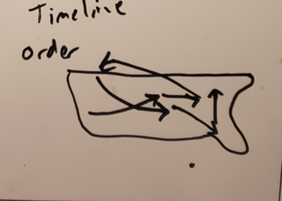

When states are hovered on, the lines are blurred so only paths relative to that state are shown. This helps see data if it gets convoluted with a lot of different visit paths.

Final Output Page

Color Choice

Our color palate has been an ongoing evolution throughout the project. We expect to change it in the future but for now, we like the palate chosen for its aesthetic properties but also its readability by persons of various color blindness anomalies.

# Evaluation

We have learned that it is possible for a user, inexperienced in visualization, to create high quality statistical representations of their data by just inputting the dates of their climbs. We are very pleased with our visualization’s ability to convey personal geographical data at this stage and find it very useful at this stage. We would like to continue working on it and add it weather data and additional links to resources nearby. We would also like to offer the user several palettes to choose from to customize their graphs to a color choice of their choosing.